A000-Asia-China-Hongshan-Dragon-3200 BCE

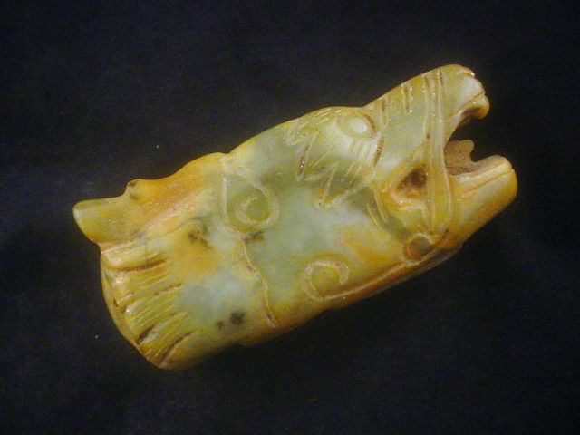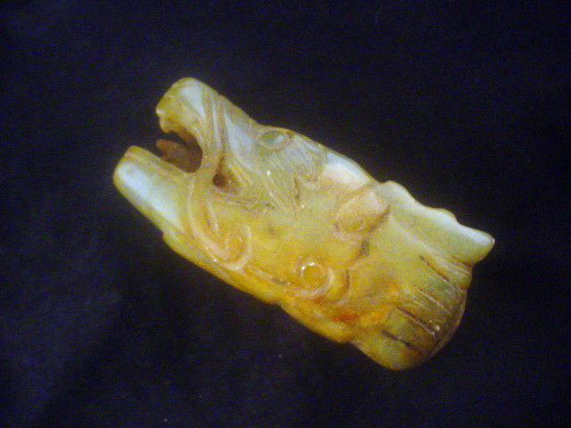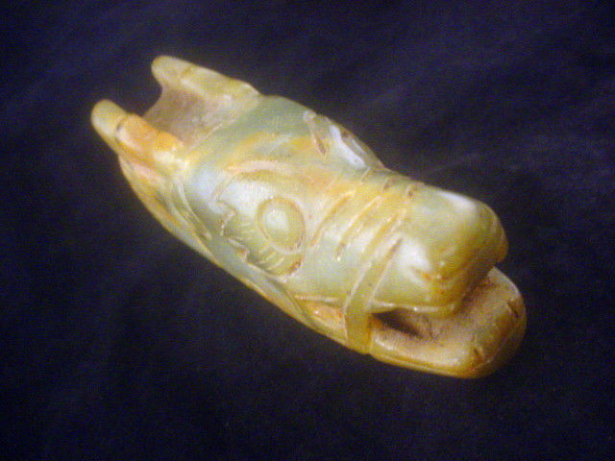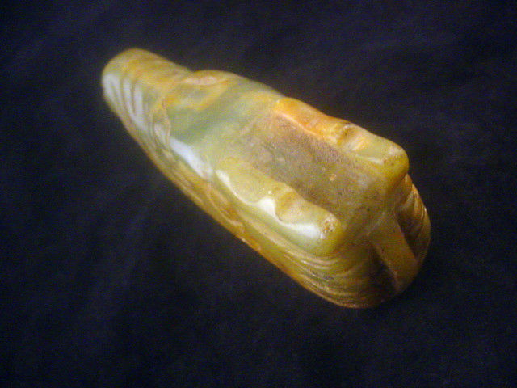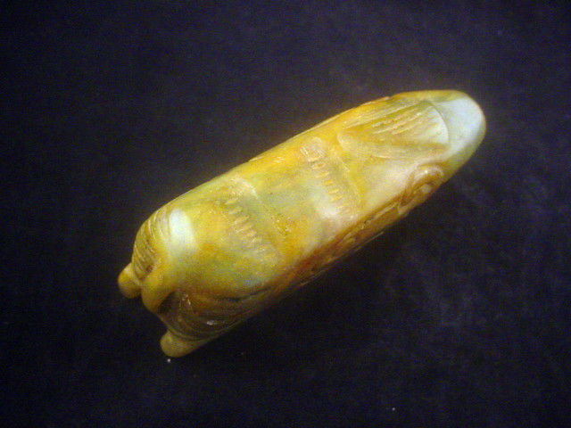

Case No.: 5

Accession No.

Formal Label:

**Display Description:**

Accession Number:

**LC Classification:**

Date or Time Horizon:

Geographical Area:

**Map:**

**GPS coordinates:**

Cultural Affiliation:

Media:

Dimensions:

Weight:

Condition:

Provenance:

**Discussion:**

**References:**